**Project Report**

**--Two-Phase Multiway Merge-Sort**

# Algorithm Description

Phase 1:

* Dived the input file into chunks of M blocks each;
* Sort each chuck individually using the M buffers;
* Write the sorted chunks to output files.

Phase 2:

* Divide the M buffers into:
* Use the M − 1 input buffers to read the K sorted chunks
* Merge sort the K sorted chunks together into a sorted file using 1 output buffer

# Analysis:

If we fix main memory, we will get different execution time based on different memory usage (%):

Main Memory:10MB and 20MB

File: T1: 240000 tuples. T2: 100000 tuples.

Tuple: 100 bytes.

Block: 40 tuples.

* The number of I/O is:

I/O number=chunks number=Number of tuples in the file/Tuples number in each chunk

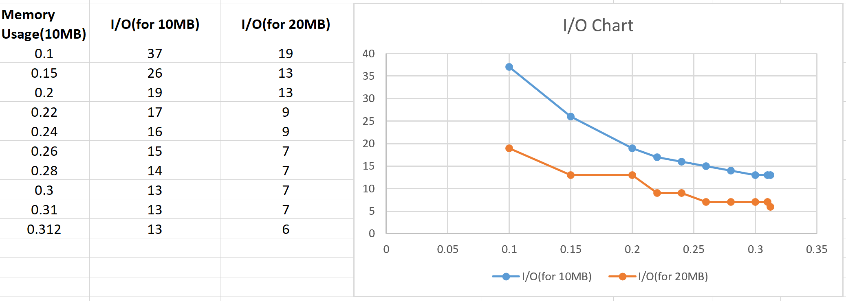

* Execution time:

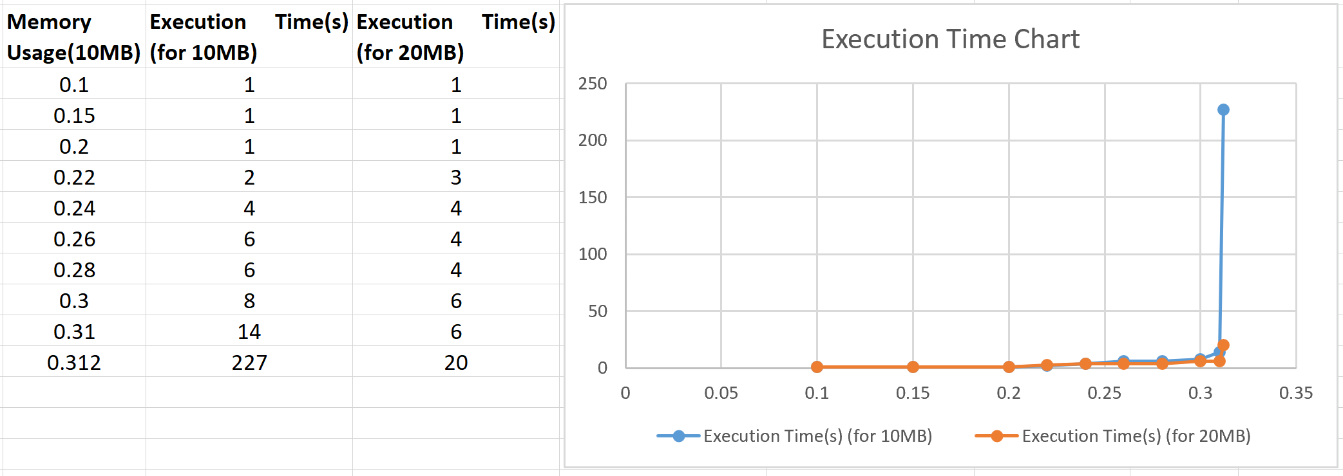

If we fix memory usage, main memory only 10MB, we will get different execution time and I/O number based on different size of chunk:

Main Memory:10MB.

File: T1: 20000 tuples. T2: 20000 tuples.

Tuple: 100 bytes.

Block: 40 tuples.

Memory usage: 0.6

